Mule Questions

Triggering Flows

Quiz

Top of Form

1. **A Flow Reference component sends a non-empty JSON object payload to another flow named childFlow, which then returns an XML body.**

**A Flow Reference component saves the payload returned from childFlow to its target attribute named payload. Refer to the exhibit.**

**What is true about the Mule event's payload at the next event processor after the Flow Reference component?**

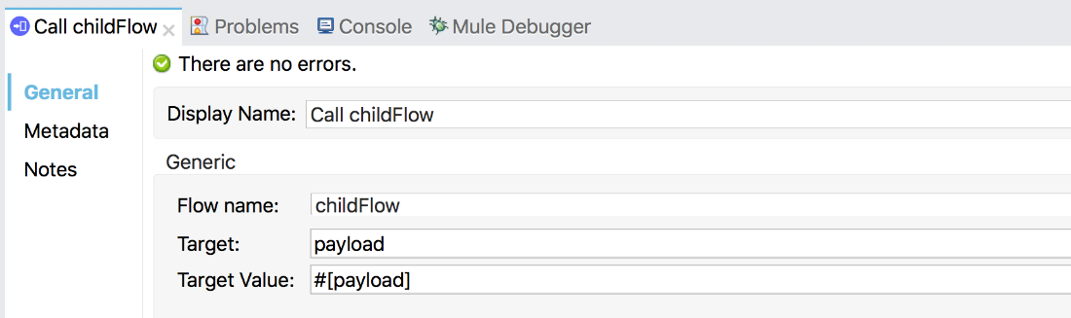



**The payload is the XML response body**



**The payload is a non-empty Java object**



**The payload is the original JSON object**



**The payload is null**

1. **Refer to the exhibit. What is the object type returned by the File List operation?**

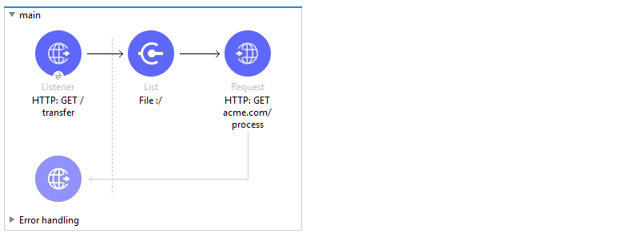



**Array of Mule event objects**



**Object of Mule event objects**



**Array of String file names**



**Object of String file names**

1. **In the Database On Table Row operation, what does the Watermark column enable the On Table Row operation to do?**



**To save the most recent records retrieved from a database to enable database caching**



**To avoid duplicate processing of records in a database**



**To enable multithreaded event processing for each record retrieved from a database**



**To save the payload into the ObjectStore for future reference**

1. **Assume that a database table contains a recordID column that always increases as new records get added to the table.**

**In a Mule application, what is the key process to enable manual watermarking for requests to a database using the Scheduler endpoint and the Database SELECT operation?**



**Save the max recordID from the set of recordIDs in an ObjectStore and reference this recordID in subsequent database requests**



**Enable automatic watermarking in the Database Select operation**



**Set the Watermark column in the Scheduler endpoint to the recordID**



**Save the max recordID from the set of recordIDs in a variable and reference this variable in subsequent database requests**

1. **A flow has a JMS Publish consume operation followed by a JMS Publish operation. Both of these operations have the default configurations.**

**Which operation is asynchronous (does not wait for a response before continuing to the next event processor) and which operation is synchronous (blocks and waits for a response or timeout before continuing to the next event processor)?**



**Publish consume: Asynchronous. Publish: Synchronous**



**Publish consume: Asynchronous. Publish: Asynchronous**



**Publish consume: Synchronous. Publish: Asynchronous**



**Publish consume: Synchronous. Publish: Synchronous**

---Bottom of Form

Processing Records

Quiz

Top of Form

1. **Refer to the exhibits. The Set Payload component sets the payload to a Map object (not an Array). The File Write operation writes out files based on this Map object.**

**How many files are written to the file system when the flow executes?**

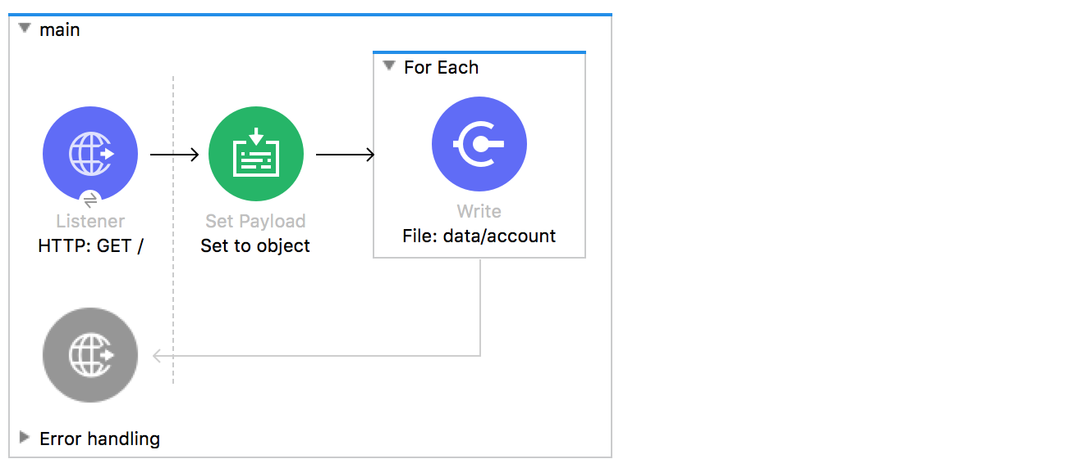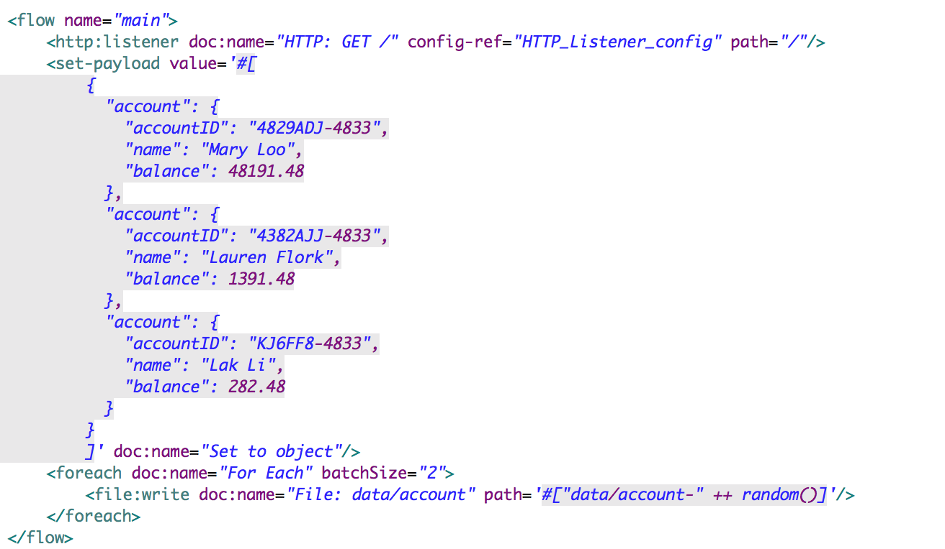



**0**



**1**



**2**



**3**

1. **Refer to the exhibit. The payload [1,2,3] is passed to the Batch Job scope. In Batch_Step_1, a variable named batchStepPayload is set to the current payload.**

**What is the value of the last log message after one batch job completes?**

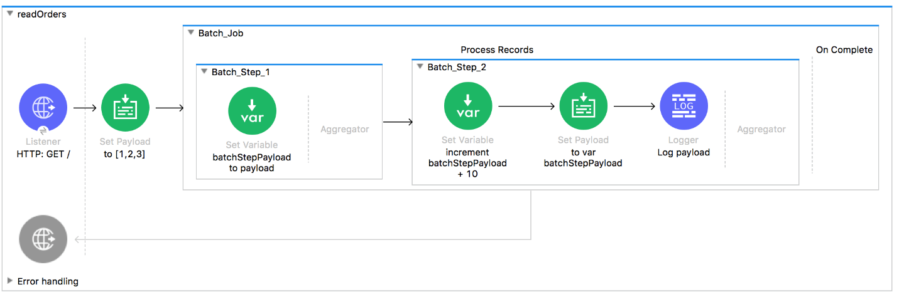



**13**



**[11,12,13]**



**33**



**30**



**10**

1. **Refer to the exhibit. What are the values of the counter and stepVar variables in the On Complete phase?**

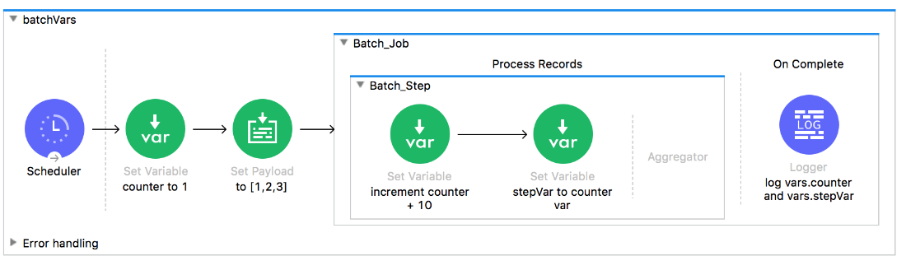



**counter: 31, stepVar: 31**



**counter: 1, stepVar: 31**



**counter: 31, stepVar: null**



**counter: 1, stepVar: null**

1. **Refer to the exhibit. What are the values of the counter and stepVar variables after the Batch Job?**

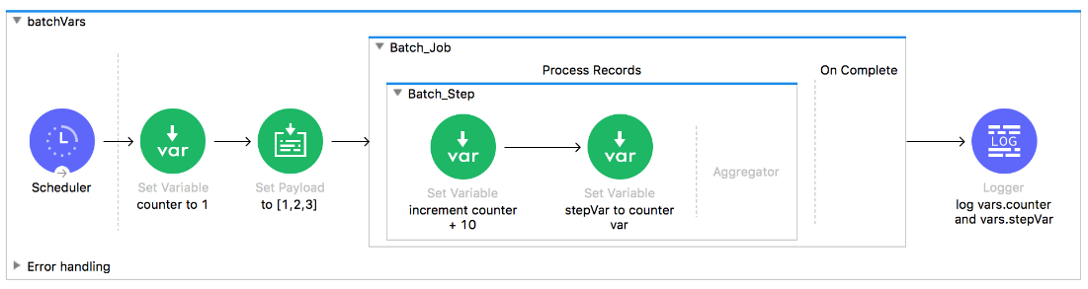



**counter: 31, stepVar: 31**



**counter: 1, stepVar: 31**



**counter: 1, stepVar: null since logger is outside the batch scope the value of variable which is outside the batch scope is taken**



**counter: 31, stepVar: null**

1. **A Batch Job scope has three batch steps. An event processor in the second batch step throws an error because the input data is incomplete.**

**What is the default behavior of the batch job after the error is thrown?**



**Event processing continues to the third batch step**



**All processing of the batch job stops**



**The second batch step is retried**



**The first batch step is retried**

1. **Refer to the exhibits. What is the output of the Logger component in the Batch Job?**

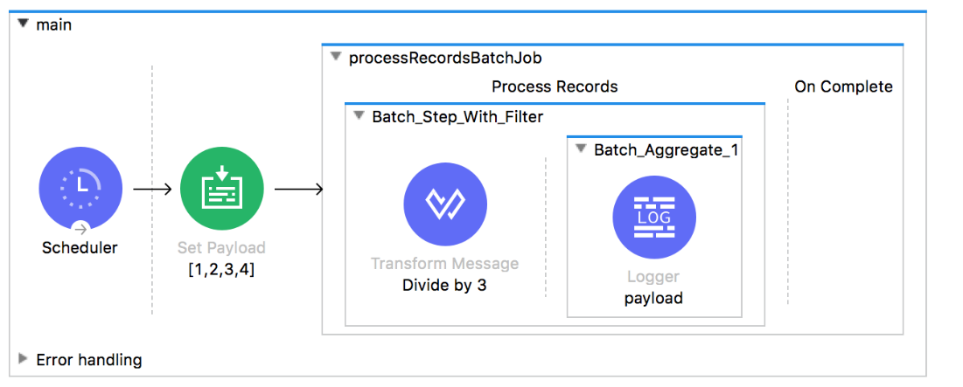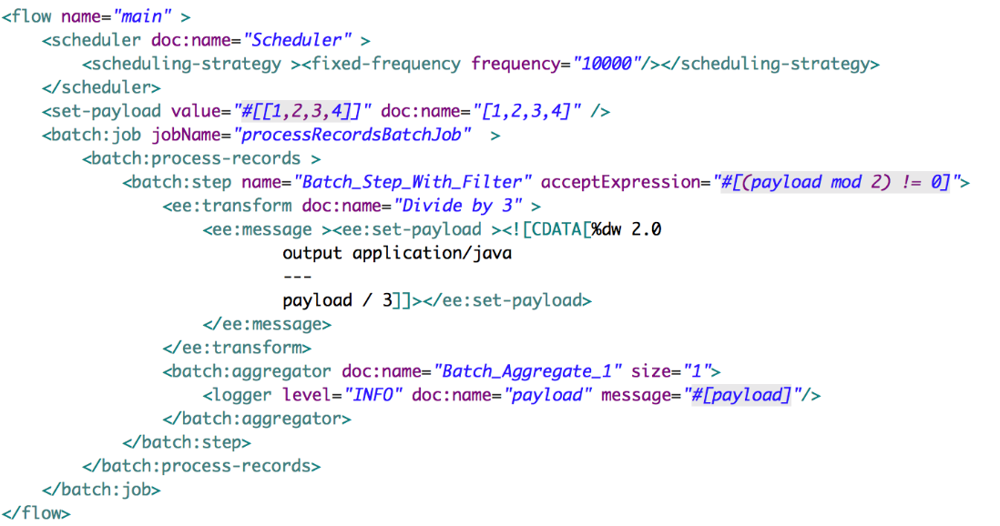

**Answers**

**A.  
[.333]  
[1]**

**B.  
[.333, 1]**

**C.  
[.333, .667, 1, 1.333]**

**D.  
[.333]  
[.667]  
[1]  
[1.333]**



**A**



**B**



**C**



**D**

---Bottom of Form

Writing DataWeave Transformations

Quiz

Top of Form

1. **Refer to the exhibit. An event payload contains an unordered array of flight objects, where every object has a price key and a toAirport key.**

**What is valid DataWeave code to return flights with price under 500, grouped by toAirport in ascending order, with the lowest price first?**

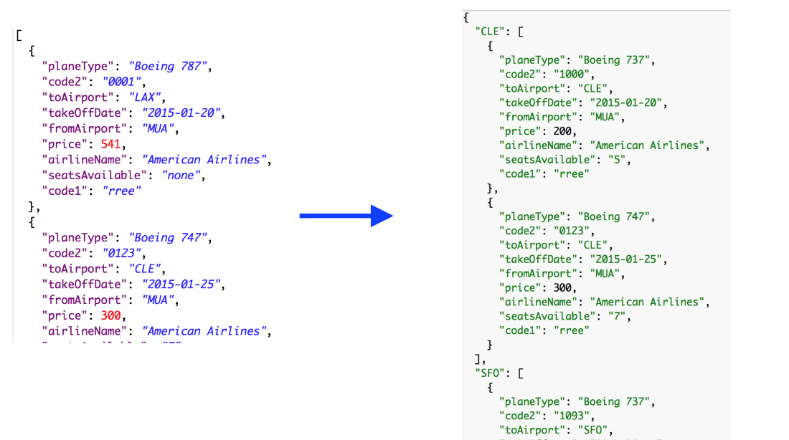



**payload groupBy $.toAirport filter $.price < 500 orderBy $.price**



**payload groupBy $.toAirport filter $.price > 500 orderBy $.price**



**payload filter $.price < 500 orderBy $.price groupBy $.toAirport**



**payload filter $.price > 500 orderBy $.price groupBy $.toAirport**

1. **Refer to the exhibit. What is valid DataWeave code to transform the input JSON payload to the output XML payload?**

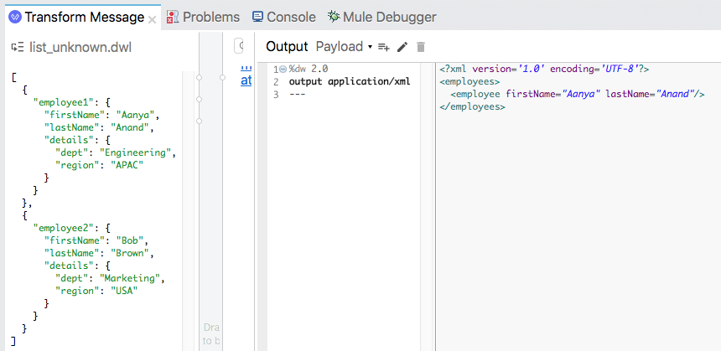

**Answers**

**A.**

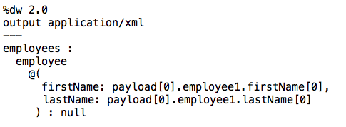

**B.**

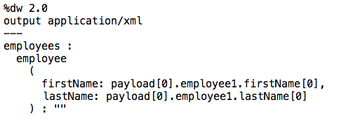

**C.**

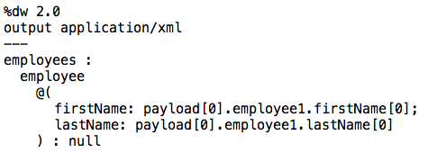

**D.**

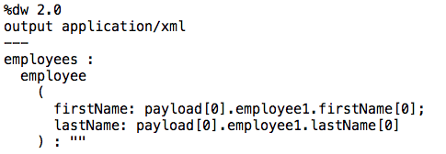



**A**



**B**



**C**



**D**

1. **A Mule application has a main flow and a combineNames flow. In the main flow, a variable named fullName is set to the object {firstName: "Max", lastName: "Mule"}.**

**What is valid DataWeave code to call the combineNames flow with the input object stored in the fullName variable?**



**#[ dw::Flow::lookup( "combineNames", vars.fullName ) ]**



**#[ dw::Runtime::lookup( "combineNames", vars.fullName ) ]**



**#[ lookup( "combineNames", vars.fullName ) ]**



**#[ combineNames( vars.fullName ) ]**



**#[ lookup( combineNames( vars.fullName ) ) ]**

1. **What DataWeave 2.0 type can be used as input to a map operation?**



**Array**



**Object**



**Map**



**String**



**Key**

1. **What is the correct way to format the decimal 20.3844 as a string to two decimal places?**



**20.3844 as String {format: ".0#"}**



**20.3844 as :string {format: ".0#"}**



**20.3844 as String as format: ".0#"**



**20.3844 as :string as format: ".0#"**



**20.3844 as String (format = ".0#")**



**20.3844 as :string (format = ".0#")**

Handling Errors

Quiz

Top of Form

1. **Refer to the exhibits. The main flow has an On Error Continue scope. In the Configuration global element, default error handler is set to globalErrorHandler.**

**A web client makes an HTTP GET request to the flow's HTTP Listener. The Is number validator then throws an error with message "Validate - Payload is an Integer".**

**What response message is returned to the web client?**

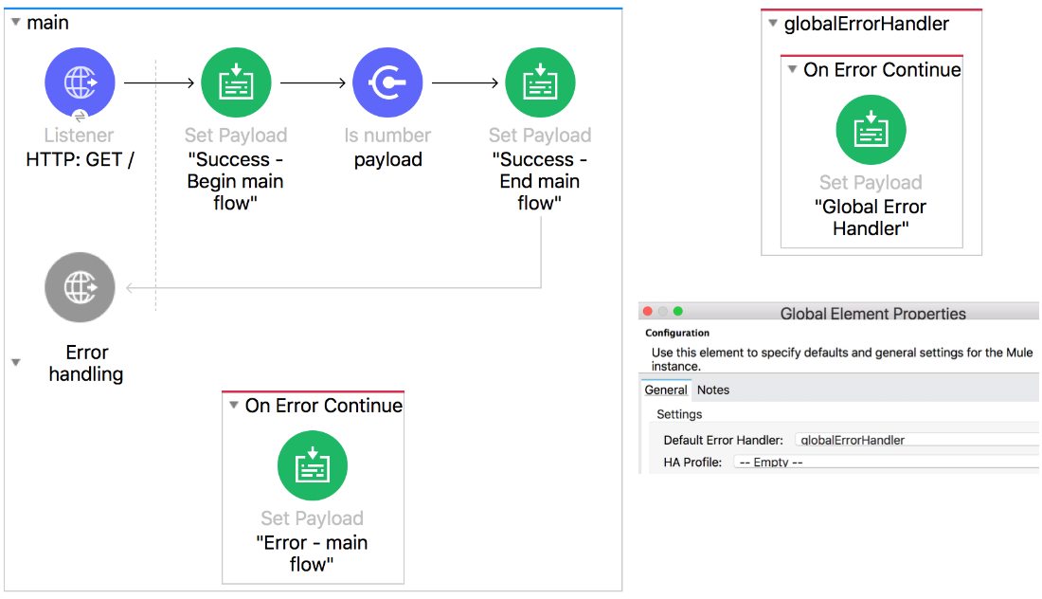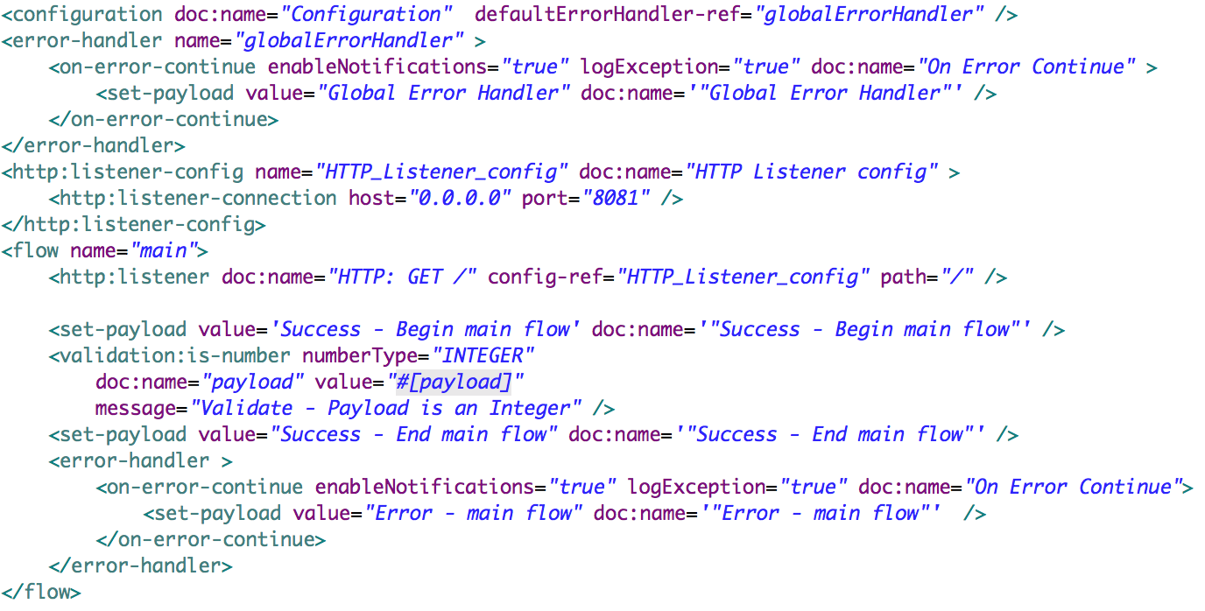



**Error - main flow**



**Success - Begin main flow**



**Success - End main flow**



**Validate - Payload is an Integer**



**Global Error Handler**

1. **Refer to the exhibits. The main flow has an On Error Propagate scope. In the Configuration global element, default error handler is set to globalErrorHandler.**

**A web client makes an HTTP GET request to the flow's HTTP Listener. The Is number validator then throws an error with message "Validate - Payload is an Integer".**

**What response message is returned to the web client?**

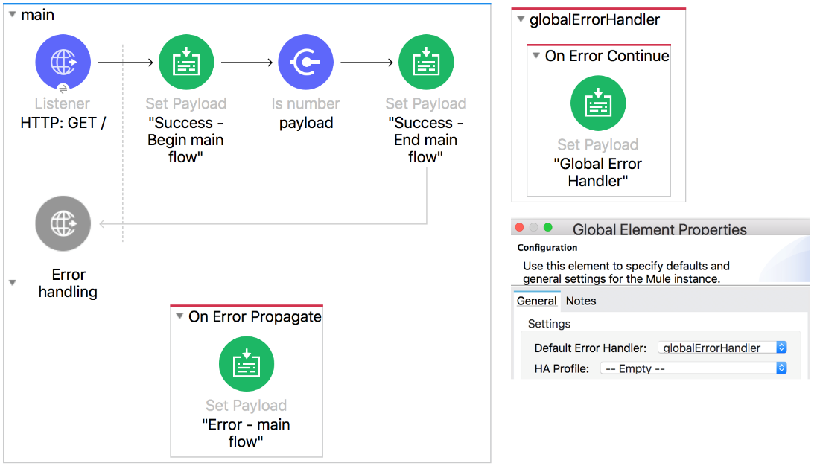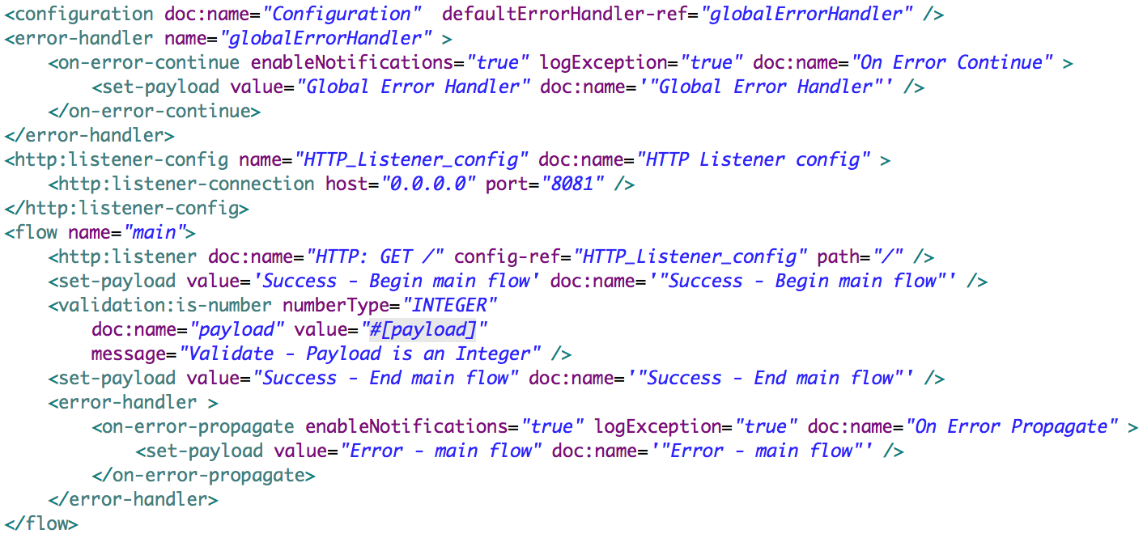



**Error - main flow**



**Success - Begin main flow**



**Success - End main flow**



**Validate - Payload is an Integer**



**Global Error Handler**

1. **Refer to the exhibits. The private flow has an On Error Propagate scope. In the Configuration global element, default error handler is set to globalErrorHandler.**

**A web client makes an HTTP GET request to the flow's HTTP Listener. The Is number validator in the private flow then throws an error with message "Validate - Payload is an Integer".**

**What response message is returned to the web client?**

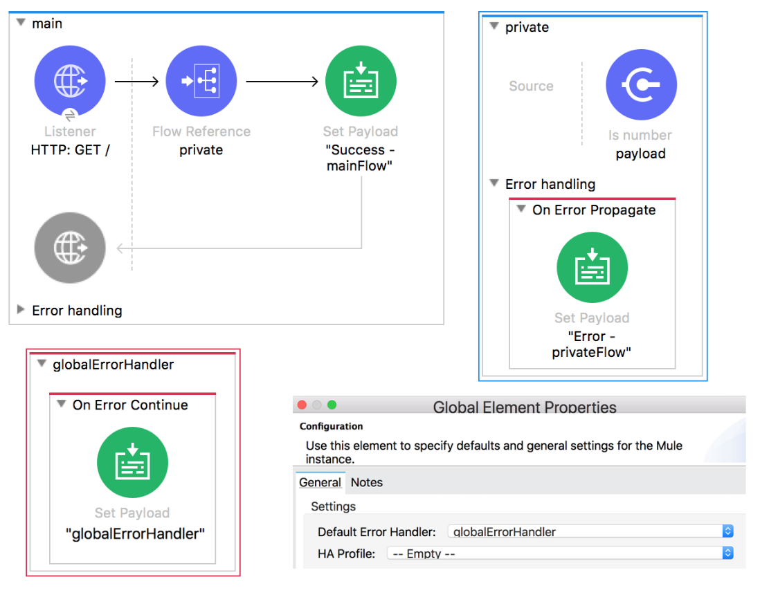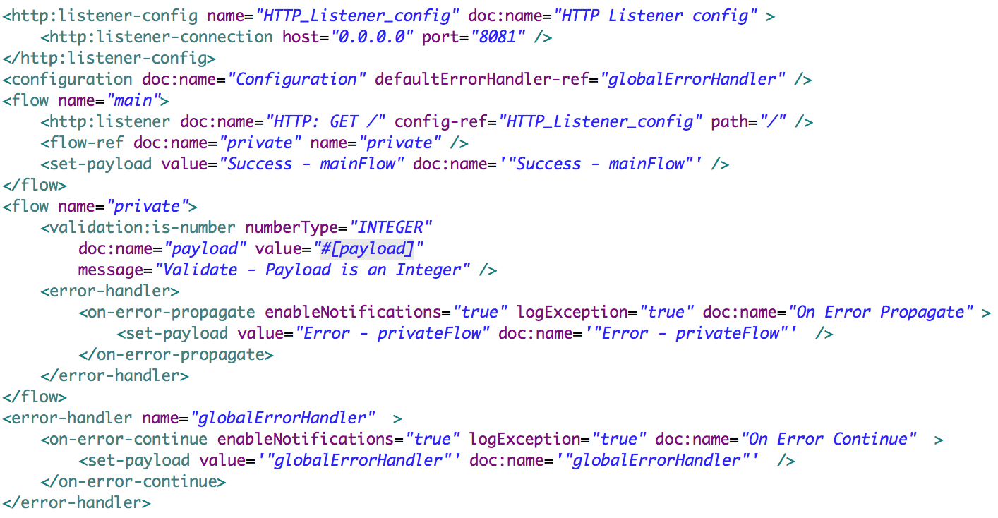



**globalErrorHandler**



**Success - mainFlow**



**Error - privateFlow**



**Validate - Payload is a Number**

1. **Refer to the exhibits. The main flow has an On Error Continue scope and the private flow has an On Error Propagate scope.**

**A web client makes an HTTP GET request to the HTTP Listener. The Is number validator in the private flow then throws an error with message "Validate - Payload is an Integer".**

**What response message is returned to the web client?**

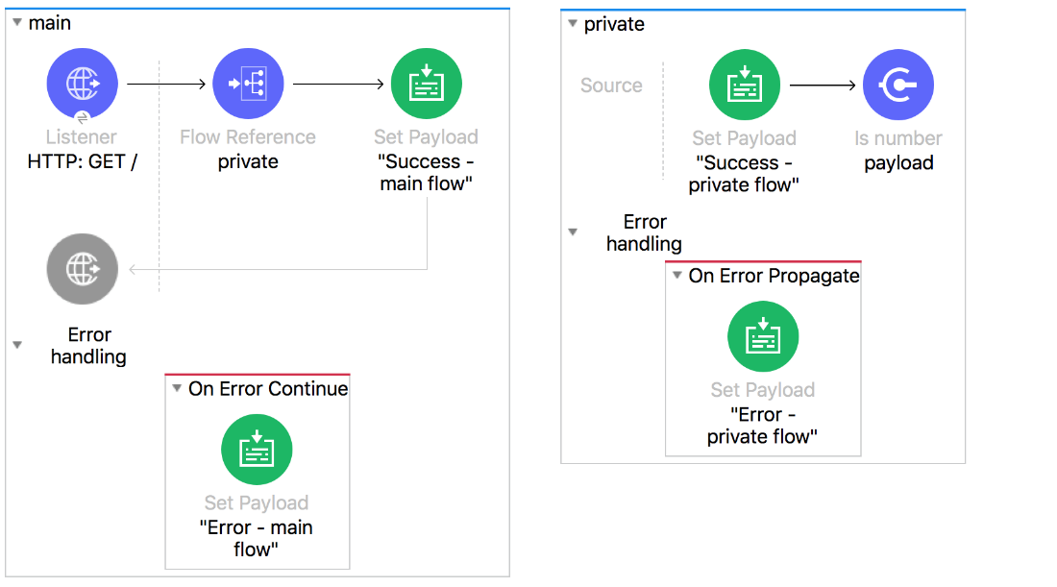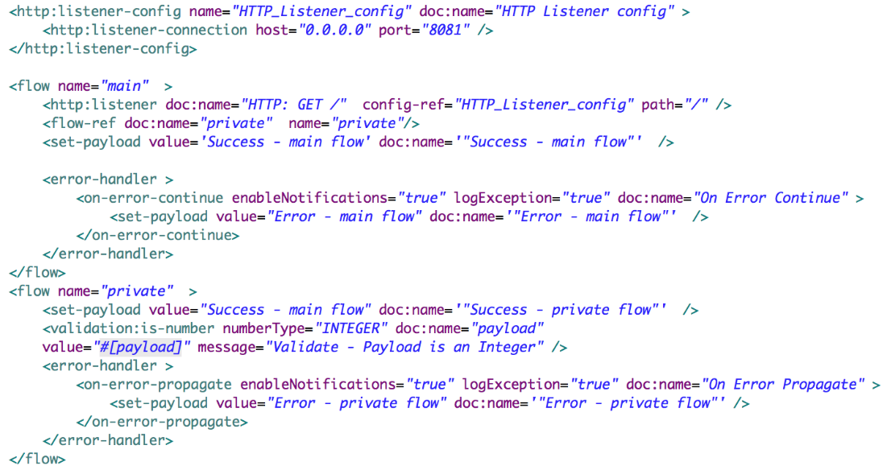



**Error - main flow**



**Success - main flow**



**Error - private flow**



**Success - private flow**



**Validate - Payload is Integer**

1. **How can an error scope be configured to catch all errors in the HTTP namespace?**

**Answers**

**A.  
  
Type: HTTP   
When:**

**B.  
  
Type: HTTP*   
When:**

**C.  
  
Type:   
When: #[ error.errorType.namespace == "HTTP" ]**

**D.  
  
Type:   
When: #[ contains "HTTP" ]**



**A**



**B**



**C**



**D**

1. **Refer to the exhibits. The main flow has an On Error Continue scope with type set to HTTP:NOT_FOUND. The Mule application configures globalErrorHandler as its default error handler.**

**A web client posts a request to the HTTP Listener. The Transform Message component then throws a MULE:EXPRESSION error trying to convert the payload to application/xml.   
   
What response message is returned to the web client?**

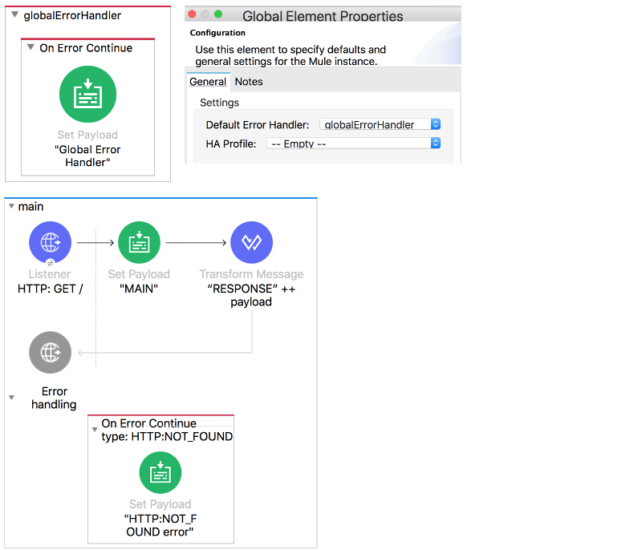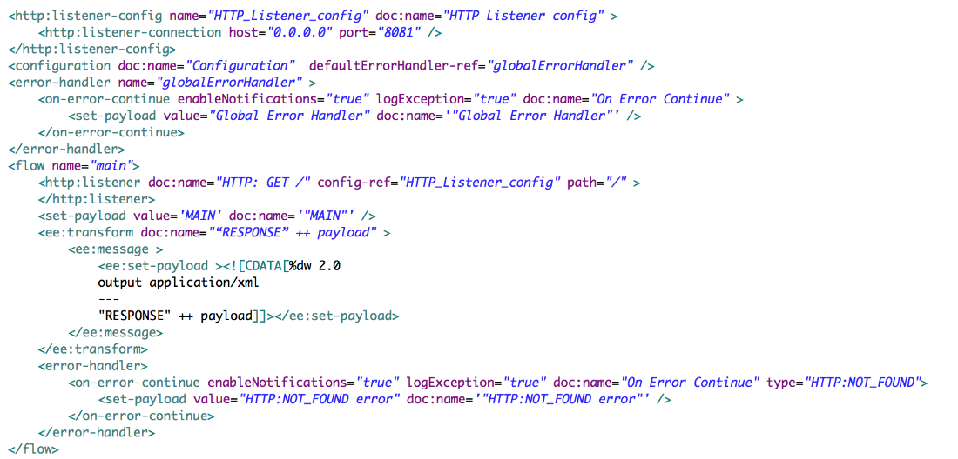



**"HTTP:NOT_FOUND error"**



**"MAIN"**



**"Global Error Handler"**



**The MULE:EXPRESSION error's message**

Controlling Event Flow

Quiz

Top of Form

1. **How are multiple conditions used in a Choice router to route events?**



**To find the FIRST true condition, then route the same event to the matched route and ALL FOLLOWING routes**



**To route the same event to the matched route of EVERY true condition**



**To find the FIRST true condition, then distribute the event to the ONE matched route**



**To filter and aggregate the responses after copying the event to EVERY route**

1. **A Scatter-Gather processes three separate HTTP requests. Each request returns a Mule event with a JSON payload.**

**What is the final output of the Scatter-Gather?**



**An Object containing all three Mule event Objects**



**An Array of the three JSON payload Objects**



**An Array of the three Mule event Objects**



**An Object containing all three JSON payload Objects**



**The last JSON payload Object**



**The last Mule event object**

1. **An event contains a payload that is an Array of Objects. How is the event routed in a Scatter-Gather?**



**The ENTIRE event is sent to each route and processed SEQUENTIALLY**



**The event is SPLIT and different SMALLER events are routed and processed in PARALLEL**



**The event is SPLIT and different SMALLER events are routed and processed SEQUENTIALLY**



**The ENTIRE event is sent to each route and processed in PARALLEL**

1. **What module and operation will throw an error if a Mule event's payload is not a number?**



**Validation module's Is number operation**



**Validation module's Is not number operation**



**Filter module's Is number operation**



**Filter module's Is not number operation**

1. **Refer to the exhibits. What happens to this flow when the Validation module's Is not null operator throws an error?**

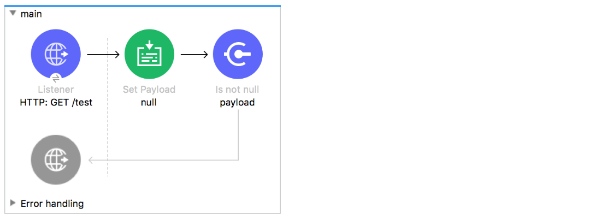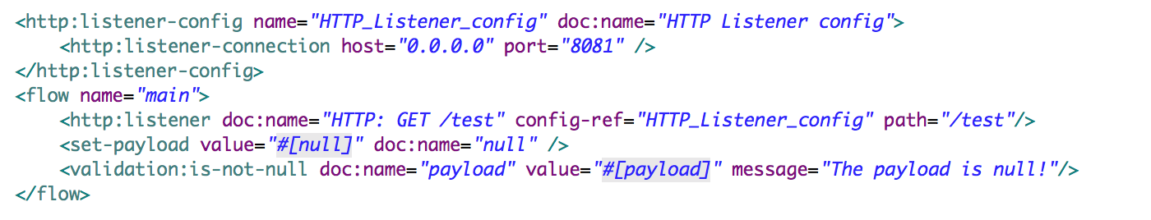



**The flow silently stops processing its Mule event**



**The flow stops processing its Mule event and returns an error message to the HTTP Listener operation**



**The flow logs the error message in the console and continues processing its Mule event**



**The flow continues processing its Mule event and appends the error message to the end of the payload**

Bottom of Form

Consuming Web Services

Quiz

Top of Form

1. **What file type is required to configure a Web Service Consumer to consume a SOAP web service?**



**RAML**



**WSDL**



**JSON**



**OAS**

1. **How are query parameters dynamically passed to an outbound REST request using an HTTP Request operation?**



**As query parameters in the HTTP Request operation**



**As URI parameters in the HTTP Request operation**



**In the Mule event's payload**



**As flow variables**



**As attributes in a Transform Message component before the HTTP Request operation**



**As attributes in the HTTP Listener operation**

1. **Refer to the exhibit. The flow calls a SOAP endpoint using the Consume operation of the Web Service Consumer. The SOAP service has a required input parameter.**

**What event processor can be used to build the SOAP envelope with the required argument to pass to the SOAP service?**

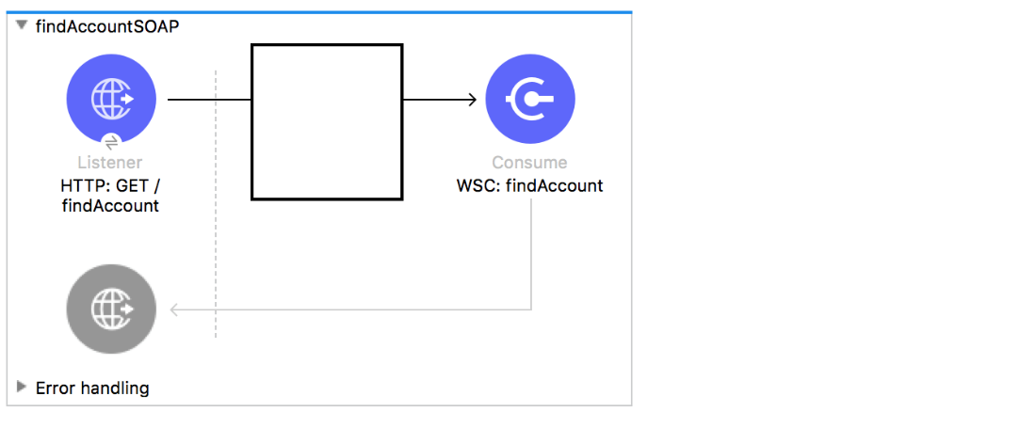



**Set Property**



**Build SOAP**



**Transform Message**



**JSON to XML**



**Set Attachement**

1. **An HTTP Request operation returns a JSON array of objects. In the Transform Message component, what is the process to convert the array of objects to an array of custom Java Account objects?**



**Add the Account object metadata to the output and use the drag-and-drop feature to transform the incoming JSON data**



**Change the output type to the Java Account object type**



**Add the Account object metadata to the input and the Transform Message component will automatically convert the JSON objects to Account objects**



**Change the input type to the Java Account object type**

1. **What is the process to create a connector using REST Connect?**



**Develop the API in flow designer and publish the API to Exchange**



**Design the API in Anypoint Studio and upload the API to Runtime Manager**



**Design the API in Design Center and publish the API to Exchange**



**Develop the API in Anypoint Studio and export the connector as a jar file**

Bottom of Form

Structuring Mule Applications

Quiz

Top of Form

1. **A Mule application has two flows named parentFlow and childFlow. A variable is defined in parentFlow.**

**What is the scope of the variable when the parentFlow calls childFlow using a Flow Reference?**



**The variable is accessible in childFlow but is immutable**



**The variable is accessible in childFlow, can be changed, and changes are seen back in parentFlow**



**The variable is NOT accessible in childFlow**



**The variable is accessible in childFlow, can be changed, but changes are NOT seen back in parentFlow**

1. **Refer to the exhibit. In the deployable archive's /classes folder, there are two properties files named dev.properties and prod.properties. The Mule application fails to deploy to CloudHub through Runtime Manager with the following error message.**

**What could be causing this error?**

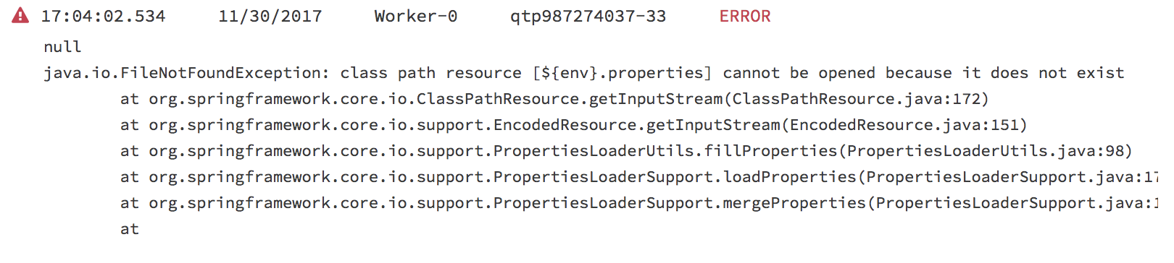



**The property files were NOT saved at the root level of the deployable archive**



**The env property is NOT set in the Runtime Manager in the Mule application's Properties tab**



**A file named ${env}.properties is NOT included in the deployable archive file**



**The dev.properties and prod.properties files were NOT uploaded to Runtime Manager**

1. **What reserved property can be defined and used in a Mule application to allow an HTTPS Listener to be accessed by external web clients after the Mule application is deployed to CloudHub?**



**${ssl.port}**



**${ssl.listener.port}**



**${https.listener.port}**



**${https.port}**

1. **Why must a Mule application's deployable archive package all its dependencies in order to be deployed to CloudHub?**



**The online logging service requires access to ALL project dependencies to log the appropriate Java classes used in the Mule application**



**CloudHub workers CANNOT download ALL possible project dependencies a project may contain**



**CloudHub workers needs to compare the current dependencies with the LATEST project dependencies from the MuleSoft repository**



**MuleSoft support requires access to ALL project dependencies for future online troubleshooting**

1. **In what file does the Mule project keep track of all of its dependencies?**



**mule-artifact.json**



**pom.xml**



**mule-app.properties**



**global.xml**

1. **What can ONLY be done with VM connectors, and NOT with Flow References, in a single Mule application?**



**Preserve variables as the Mule event gets passed to another flow**



**Allow a flow to pass events to another flow synchronously**



**Preserve the original payload when the VM connector returns a response from a flow**



**Allow a flow to pass events to another flow asynchronously**

Introducing Application Networks and API-Led Connectivity

Quiz

Top of Form

1. **What MuleSoft API-led connectivity layer is intended to expose part of a backend database without business logic?**



**Experience**



**Data**



**System**



**Process**



**Security**

1. **What statement is part of MuleSoft's description of an application network?**



**Creates reusable APIs and assets designed to be consumed by other business units**



**Creates and manages high availability and fault tolerant services and infrastructure**



**Leverages Central IT to deliver complete point-to-point solutions with master data management**



**Creates and manages a collection of JMS messaging services and infrastructure**

1. **According to MuleSoft, what is the Center for Enablement's role in the new IT operating model?**



**Creates and manages discoverable assets to be consumed by line of business developers**



**Centrally manages partners and consultants to implement line of business projects**



**Implements line of business projects to enforce common security requirements**



**Produces and manages API policies for line of business deployments**

1. **What is a core characteristic of the Modern API?**



**API is designed first using an API specification for rapid feedback**



**API is rapidly prototyped following AGILE methodology**



**API follows the RESTful architecture**



**API has a mechanism to accept feedback and suggestions for improvement**

1. **Refer to the exhibit. The API specification supports searching for articles on the searchworld.org site.**

**What is the most idiomatic (used for its intended purpose) URL and method to retrieve articles about "einstein" in XML format?**

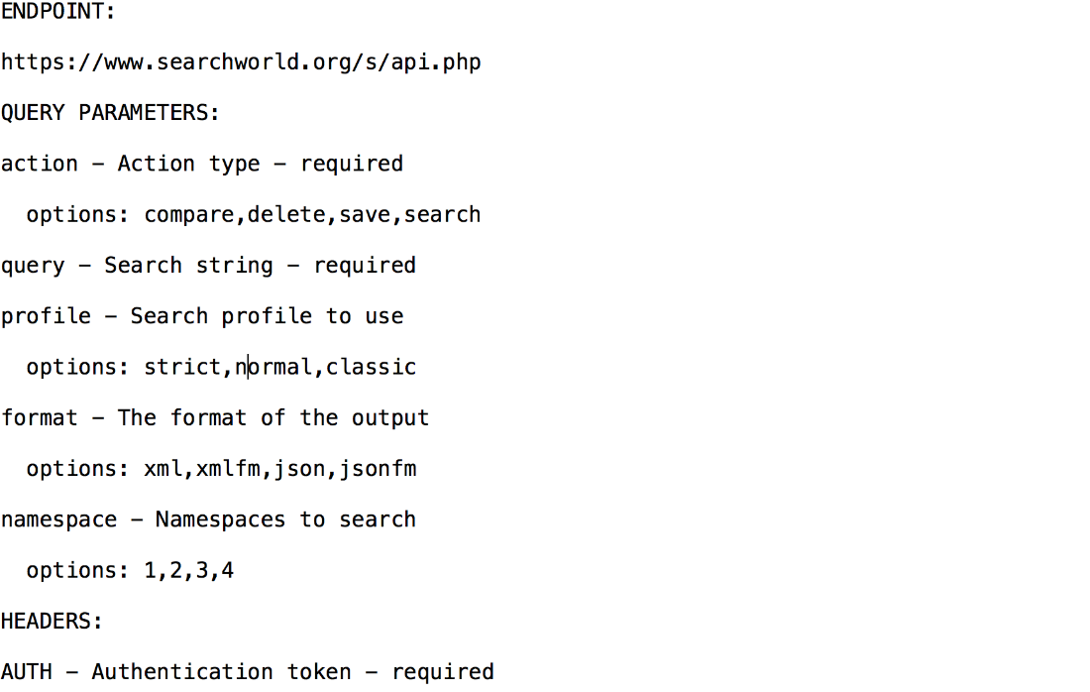

**Answers**

**A.**

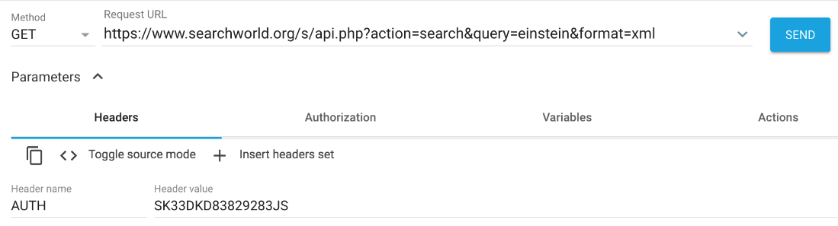

**B.**

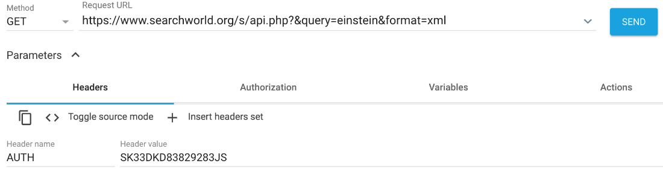

**C.**

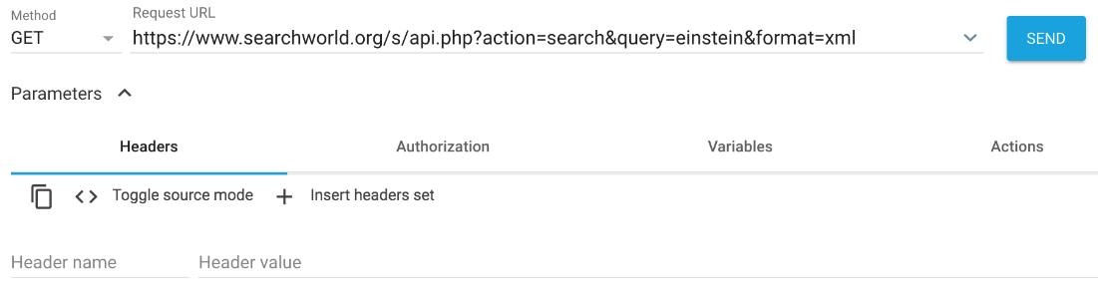

**D.**

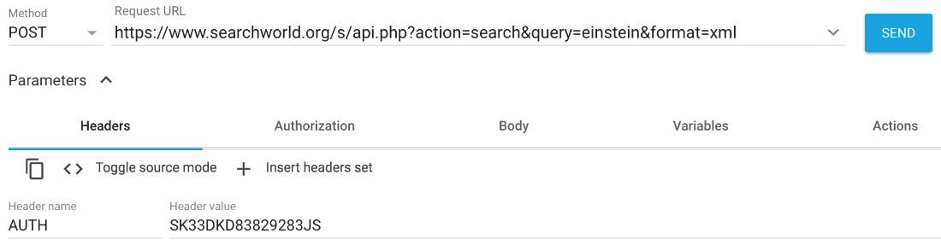



**A**



**B**



**C**



**D**

1. **What HTTP method in a RESTful web service is typically used to completely replace an existing resource?**



**PATCH**



**PUT**



**POST**



**GET**

Bottom of Form

Bottom of Form

--Bottom of Form

Introducing Anypoint Platform

Quiz

Top of Form

1. **What is the main purpose of flow designer in Design Center?**



**To design API RAML files in a graphical way**



**To design and develop fully functional Mule applications in a hosted development environment**



**To define API lifecycle management in a graphical way**



**To design and mock Mule application templates that must be implemented using Anypoint Studio**

1. **Where does a deployed flow designer application run in Anypoint Platform?**



**Exchange**



**CloudHub worker**



**API Manager**



**Design Center**

1. **What MuleSoft product enables publishing, sharing, and searching of APIs?**



**API Designer**



**Runtime Manager**



**Anypoint Exchange**



**API Notebook**

1. **What asset can NOT be created using Design Center?**



**API Specifications**



**Mule Applications**



**API Fragments**



**API Portals**

1. **A web client submits a GET request to a Mule application to the endpoint /customers?id=48493.**

**Where is the id stored in the Mule event by the HTTP Listener?**



**Inbound Properties**



**Variables**



**Attributes**



**Payload**

## --Designing APIs

Quiz

Top of Form

1. **An API has been created in Design Center. What is the next step to make the API discoverable?**



**Deploy the API to a Maven repository**



**Enable autodiscovery in API Manager**



**Publish the API from inside flow designer**



**Publish the API to Anypoint Exchange**

1. **Refer to the exhibit. What is the correct URL to submit a GET request to /patients?**

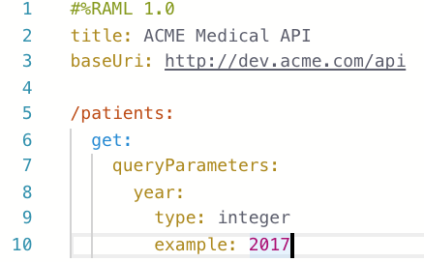



**http://dev.acme.com/patients?year=2016**



**http://dev.acme.com/api/patients**



**http://dev.acme.com/patients**



**http://dev.acme.com/api/patients?year=2016**

1. **A RAML example fragment named BankAccountsExample.raml is placed in the examples folder in an API specification project.**

**What is the correct syntax to reference the fragment?**



**examples: !include BankAccountsExample.raml**



**examples: #import BankAccountsExample.raml**



**examples: !include examples/BankAccountsExample.raml**



**examples: #import examples/BankAccountsExample.raml**

1. **Refer to the exhibit. There is an error in the flight_id resource's GET method. What needs to be done to fix the problem?**

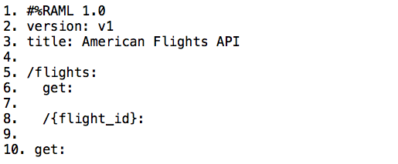



**Remove blank line on row 9**



**Enclose flight_id in parentheses () instead of curly braces {}**



**Indent the get method under the {flight_id} resource**



**Outdent the {flight_id} resource**



**Remove the curly braces {} around flight_id**

1. **Refer to the exhibit. This RAML specification includes an XML example that matches the Records data type defined in another RAML file named recordsDataType.raml.**

**Using the Records type, how can this XML example be represented in RAML?**

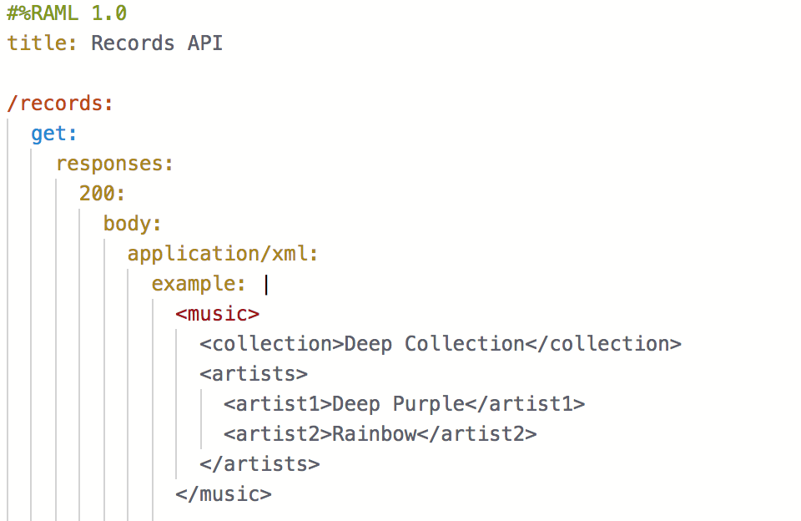

**Answers**

**A.**

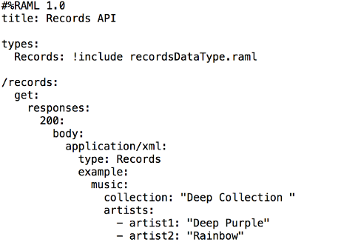

**B.**

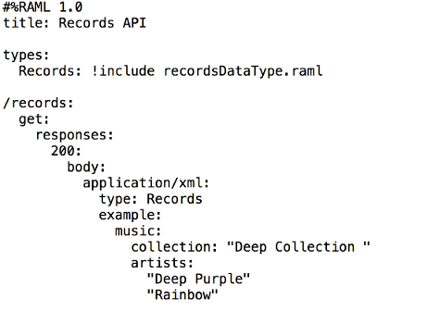

**C.**

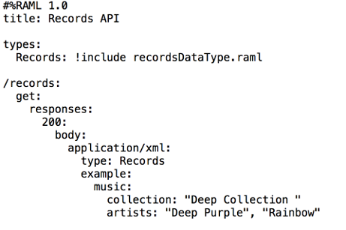

**D.**

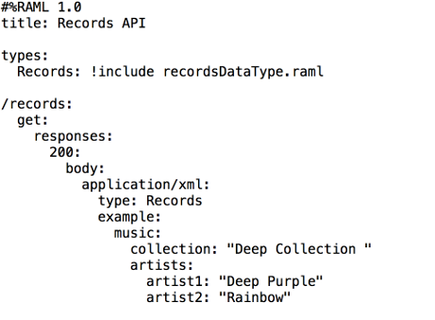



**A**



**B**



**C**



**D**

## -Building APIs

Quiz

Top of Form

1. **What is the purpose of the api:router element in APIkit?**



**Creates native connectors using a 3rd party Java library**



**Serves as an API implementation**



**Validates requests against RAML API specifications and routes them to API implementations**



**Validates responses returned from API requests and routes them back to the caller**

1. **What is the minimum required configuration in a flow for a Mule application to compile?**



**An event processor**



**An event source**



**A Logger component**



**A project RAML file**

1. **A Database connector is configured to select rows from a MySQL database.**

**What is the format of the array of results returned from the database query?**



**Java**



**JSON**



**XML**



**CSV**

1. **What is NOT part of a Mule 4 event?**



**message**



**payload**



**inboundProperties**



**attributes**

1. **How does APIkit determine the number of flows to generate from a RAML specification?**



**Creates a separate flow for each resource**



**Creates a separate flow for each resource that contains child resources**



**Creates a separate flow for each HTTP method**



**Creates one flow for the entire API spec**



**Creates a separate flow for each response status code**

Deploying and Managing APIs

Quiz

Top of Form

1. **What is the purpose of API autodiscovery?**



**Enables API Manager to discover the published API on Anypoint Exchange**



**Allows the Mule application to be automatically discovered on Anypoint Exchange**



**Enables an API to be directly managed in API Manager**



**Allows a deployed Mule application to connect with API Manager to download policies and act as its own API proxy**

1. **How many Mule applications can run on a CloudHub worker? (Choose one)**



**At most one**



**At least one**



**Depends on the vCores of the worker**



**Depends on the number of CloudHub workers configured**

1. **What does an API proxy application NOT do?**



**Determine which request Mule event is allowed to pass through to the API backend service**



**Apply runtime policies to enforce governance**



**Determine which response Mule event is allowed to pass through to the API backend service**



**Meters the traffic flowing through the proxy**

1. **What does the Mule runtime use to enforce policies and limit access to APIs?**



**Anypoint Access Control**



**The proxy created by API Manager**



**API Manager**



**The Mule runtime's embedded API Gateway**

1. **API Manager has been configured to enforce an SLA policy and the RAML spec has been updated with the required client_id and client_secret header requirements.**

**The new RAML spec has been published to Anypoint Exchange.**

**What is the next step to gain access to the API?**



**POST a JSON object to the /api/register endpoint of the API proxy**



**Request access to the API in Anypoint Exchange**



**Email the organization administrators to request access to the API**



**Add a client application to the Anypoint Platform organization**

## -Accessing and Modifying Mule Events

Quiz

Top of Form

1. **What happens to the attributes of a Mule event in a flow after an outbound HTTP Request is made?**



**New attributes may be added from the HTTP response headers, but no headers are ever removed**



**Previous attributes are passed unchanged**



**Attributes do not change**



**Attributes are replaced with new attributes from the HTTP Request response (which might be null)**

1. **A Set Variable component saves the current payload to a variable with the name: images. What is the DataWeave expression to access the images variable?**



**#[payload.images]**



**#[images]**



**#[flowVars.images]**



**#[vars.images]**

1. **A web service implements an API to handle requests to http://acme.com/customers/{state}.**

**A web client makes a request to this API implementation at http://acme.com/customers/CA.**

**What is the correct DataWeave expression to retrieve the value CA?**



**#[message.payload.inboundProperties.'http.uri.params'.state]**



**#[attributes.uriParams.state]**



**#[attributes.'http.uri.params'.state]**



**#[message.inboundProperties.'http.uri.params'.state]**



**#[state]**

1. **A flow contains an HTTP Listener as the event source. What is the DataWeave expression to log the Content-Type header using a Logger component?**



**#["Content-Type: " ++ attributes.headers.'content-type']**



**#["Content-Type: " + headers.'content-type']**



**#["Content-Type: " + attributes.headers.'content-type']**



**#["Content-Type: " ++ headers.'content-type']**

1. **Refer to the exhibit. What is the correct DataWeave expression for accessing the city Cleveland from the JSON payload?**

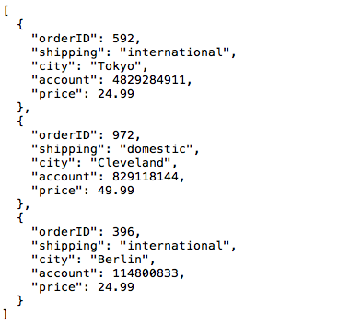



**#[payload[2].city]**



**#[payload[1].city]**



**#[payload.city[1]]**



**#[payload.city[2]]**

1. **What is NOT part of a Mule 4 event?**



**message**



**payload**



**outboundProperties**



**variables**



**attributes**

1. **A Mule application has two flows named parentFlow and childFlow. The childFlow begins with an HTTP Listener.**

**A variable is defined in parentFlow, then an HTTP Request is made to childFlow's HTTP Listener with some headers set.**

**What is the scope of the variable and attributes in the parentFlow after childFlow returns a response?**



**The variable is accessible. All the attributes passed to childFlow are removed or replaced.**



**The variable is NOT accessible. All the attributes passed to childFlow are removed or replaced.**



**The variable is NOT accessible. All the attributes passed to childFlow are preserved.**



**The variable is accessible. All the attributes passed to childFlow are preserved.**

1. **A Mule application has a flow named parentFlow.**

**The parentFlow contains an HTTP Request operation at the end of the flow. The parentFlow also contains a Set Variable operation right before the HTTP Request operation.**

**What is the scope of the variable to the server receiving the HTTP Request from parentFlow?**



**The variable is accessible in the server but is immutable**



**The variable is accessible in the server, can be changed, and changes are seen back in parentFlow**



**The variable is NOT accessible in the server**



**The variable is accessible in the server, can be changed, but changes are NOT seen back in parentFlow**

**Search Transport Barrier**

Bottom of Form

Bottom of Form

Bottom of Form

Bottom of Form

Bottom of Form